Mini Project Report
Console Record-Management Application
Student Record Management System (Python)
Submitted by: Shubham Eknath Sukhadare
Roll No --53
Submitted as part of MCA coursework
Language: Python

GITHUB LINK:- https://github.com/shubhhh25/Record_Management_System.git

1. Introduction & Objective
This project is a console-based Student Record Management System built in Python. It allows a user to Add, View, Search, Update, Delete, and Export student records through a simple, menu-driven text interface. All records are saved permanently to a JSON file, so data is not lost when the program is closed and reopened.
The objective of this mini project is to demonstrate the practical use of core Python programming concepts within a single, working application: data types and variables, conditional statements, loops, functions, exception handling, file I/O, and menu-driven program design.

2. How the Project Meets the Assignment Requirements
Requirement | How it is Implemented
Data types & variables | int for age, str for ID/name/course/email/phone; dict for one record
Conditional statements | if / elif / else used for menu routing and field validation
Loops | while True drives the main menu; for loops search and display records
Functions | One dedicated function per feature (add_record, view_records, search_record, etc.)
Exception handling | try/except around age input, menu choice input, and all file read/write operations
File I/O | json.load() / json.dump() read and write students.json
Menu-driven design | Numbered menu inside a while loop routes to the correct function each time

3. Project Theme & Data Structure
Theme: Student Record Management System — a realistic and simple theme suitable for an MCA-level assignment.

Each student record contains:
- Student ID (text) — unique identifier for each student
- Name (text)
- Age (whole number)
- Course (text)
- Email (text)
- Phone Number (text — not a number, since no arithmetic is ever done on it)

Data structure used: a list of dictionaries
Each individual student record is stored as a Python dictionary (key–value pairs), which makes each field self-describing, e.g. student["name"]. All student dictionaries are kept inside one Python list. This structure maps directly onto JSON, so the entire list can be saved to and loaded from students.json with very little code.

4. Tools & Technologies Used
Tool / Library | Purpose
Python 3 | Core programming language
json (standard library) | Save and load records permanently in students.json
os (standard library) | Check whether students.json already exists
openpyxl (external library) | Export records into a real, formatted Excel (.xlsx) report

5. Program Architecture / Flow
- Program starts → tries to load existing records from students.json (if the file is missing or corrupted, it safely starts with an empty list)
- Main menu is displayed in a while loop
- User enters a choice (1–7)
- The matching function runs (Add / View / Search / Update / Delete / Export)
- Any change to the data is immediately saved back to students.json
- The loop repeats until the user selects Exit (7)

6. Menu Options
# | Option | Description
1 | Add Record | Add a new student, with duplicate-ID and empty-field checks
2 | View Records | Display every stored student record
3 | Search Record | Look up one student by Student ID
4 | Update Record | Edit an existing student's details (blank = keep old value)
5 | Delete Record | Remove a student record, with a yes/no confirmation
6 | Export Records to Excel | Save all records into a formatted students_report.xlsx file
7 | Exit | Close the program

7. Step-by-Step Working (with Console Screenshots)
The following screenshots were captured from an actual run of the program, showing each of the 7 menu options in action.

Step 1 — Main Menu
When the program starts, it loads existing records (if any) and displays the main menu. The user picks an option by typing its number.
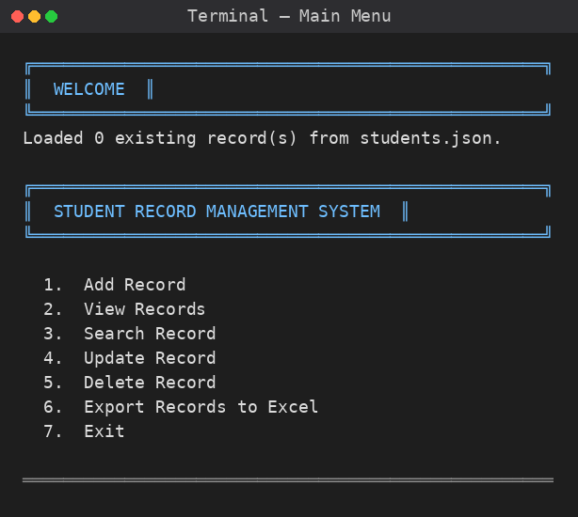
Figure 1: Program startup and main menu

Step 2 — Add Record
The user is prompted field-by-field for the new student's details. Empty fields and duplicate Student IDs are rejected automatically.
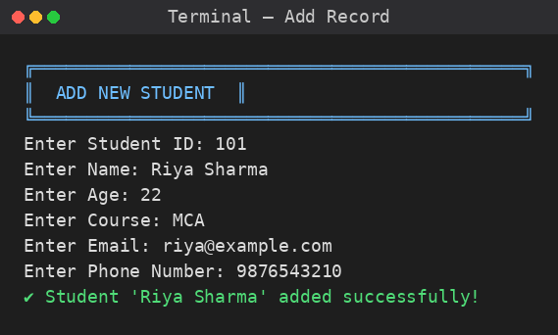
Figure 2: Adding a new student record

Step 3 — View Records
All stored records are displayed as neatly formatted cards, one per student.
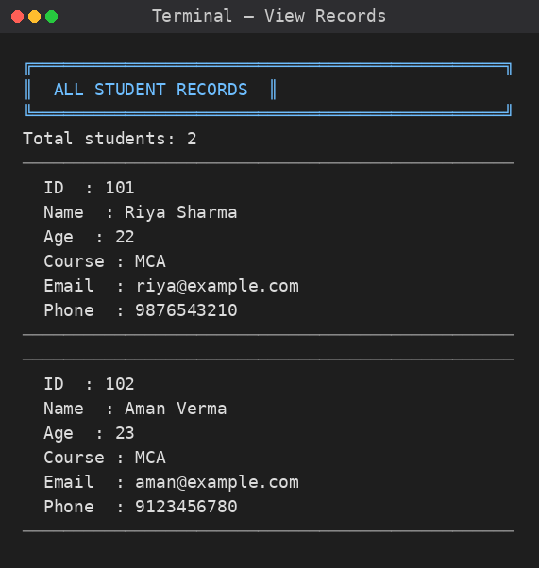
Figure 3: Viewing all student records

Step 4 — Search Record
The user enters a Student ID, and the matching record (if found) is displayed.
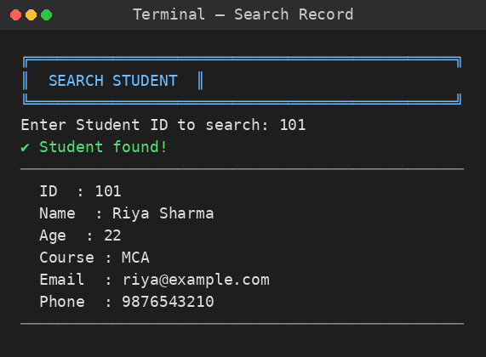
Figure 4: Searching for a student by ID

Step 5 — Update Record
The user selects a Student ID to edit. Leaving a field blank keeps its existing value, so only the fields that need changing are retyped.
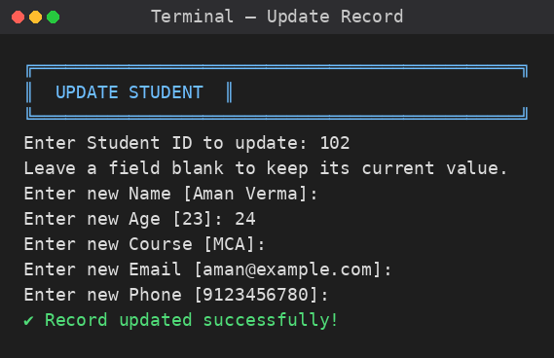
Figure 5: Updating a student's age

Step 6 — Delete Record
The matching record is shown first, then the user must confirm with 'y' before it is permanently removed.
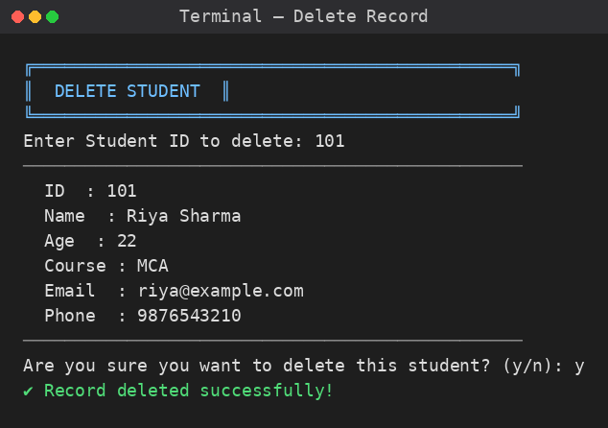
Figure 6: Deleting a student record with confirmation

Step 7 — Export Records to Excel
All current records are written into a real, formatted Excel file (students_report.xlsx) using the openpyxl library.
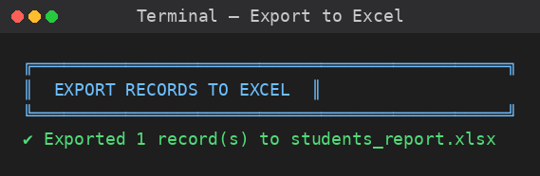
Figure 7: Exporting records to an Excel file

8. Exception Handling Summary
Situation | How it's Handled
Non-numeric age entered | try/except ValueError re-asks until a valid number is given
Invalid menu choice (text or out-of-range) | try/except ValueError plus if/elif/else range check
students.json missing | os.path.exists() check — program starts with an empty list, no crash
students.json corrupted / invalid JSON | except json.JSONDecodeError — warns and starts fresh
File cannot be read/written | except IOError around file operations
Searching/updating/deleting a non-existent ID | find_student_by_id() returns None, handled with a clear message
Duplicate Student ID on Add | Checked before insertion; add is rejected with an error message

9. Sample Test Cases
Test Case | Input | Expected Result
Add valid record | Valid details | Record added
Duplicate ID | Existing ID | Error message shown
Invalid age | "abc" | Program asks again
Search existing ID | Existing ID | Record displayed
Search invalid ID | Non-existing ID | "Not found" message
Update record | Existing ID | Record updated
Delete record | Existing ID + "y" | Record deleted
Missing students.json | No file present | Program starts with 0 records, no crash
Export to Excel | Choice 6 | students_report.xlsx created
Exit | Choice 7 | Program closes cleanly

10. Conclusion
This mini project successfully implements a menu-driven Student Record Management System that satisfies every requirement of the assignment. It demonstrates practical use of Python data types, conditionals, loops, functions, exception handling, and file I/O within one cohesive, beginner-friendly application. Records persist across program runs using JSON storage, and an additional Excel export feature makes the data easy to share and present.

